**YEAR 12 PHYSICS**

**FRICTION INVESTIGATION**

Final Report Due: _____ / _____ / _____

**‘Warm up’ question – truck arrester beds.**

The photographs on the right show the ‘emergency truck arrester bed’ near the bottom Great Eastern Highway near Midland. It’s located near the bottom of the very long Greenmount Hill.

Large trucks carrying heavy loads are in danger of experiencing brake failure when going down a steep hill. The driver of such a runaway truck has the chance to steer their truck onto the arrester bed to make an emergency stop. The arrester bed has a deep layer of gravel, which is soft enough to provide the necessary retarding force to stop the truck within the length of the bed (about 200 m).

Problem

An 11-tonne truck on Greenmount Hill experiences brake failure and begins to freewheel down the hill. The motion can be considered frictionless as it descends the hill. The driver steers the truck onto the arrester bed, which thankfully brings it to a stop in 120 m. If the truck was at an altitude 80 m above the arrester bed when its brakes failed, calculate the average force exerted by the gravel as it brings the truck to a stop.

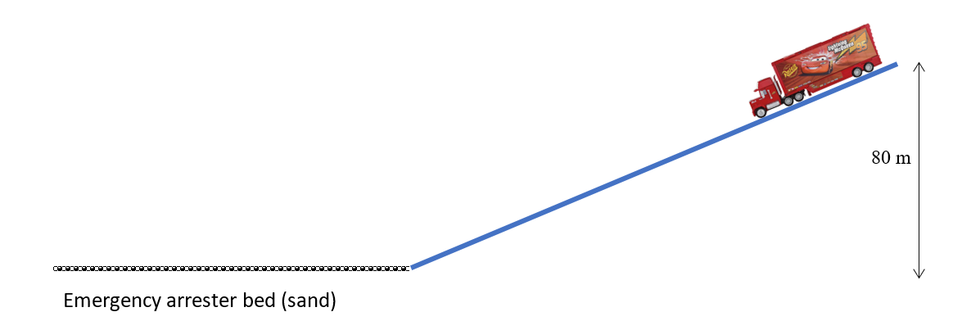

You are now ready for the investigation!

AIM

To study the effect of weight on rolling friction on a carpet.

**NOTES ON METHOD**

We will use an incline to accelerate the trolley to (hopefully!) the same known velocity each trial. The trolley will then hit the horizontal carpet (the floor) and the friction between the carpet and the wheels will decelerate the trolley to rest. In this way (and by making a few obvious assumptions) we can calculate the average frictional force on the trolley when on the carpet.

carpet

ramp

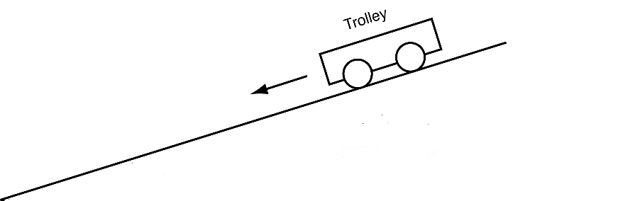

**A**

ramp

**B**

**C**

**PART 1 – Testing the ramp**

Ideally, the ramp we use will have negligible rolling friction and this should be the case with a good trolley and a ramp with a hard surface. However, it is possible to test this assumption, so we should make the attempt. Measuring the length of the trolley’s path on the ramp, and the time it takes to reach the bottom and performing a simple calculation allows us to test whether the acceleration is close to the theoretical frictionless acceleration we expect down an incline at a given angle, θ. However, much will depend on how accurate your measured time is.

Set up this ‘pre experiment’ and analyse the results. If you can definitively show that the ramp is nearly frictionless, then assume it is. Otherwise, you will need to use your results from Part 1 to calculate the expected final velocity at this angle and use this number for Part 2.

**PART 2 – The investigation**

You will be varying the mass in the trolley, but if time permits, you should perform the experiment for at least two different ramp angles – for comparison. Although we are not testing different starting velocities (i.e. ramp angles), trying it for at least 2 angles will at least give you an idea whether speed is a factor that affects frictional force

**NOTES ON EQUIPMENT**

Below is a list of some obvious equipment you will need. This is enough to perform the basic measurement of the average frictional force, but more equipment will be needed if your experiment is to be as thorough or accurate as possible. This may be equipment you can supply yourself (materials/devices/equipment you carry with you at school every day), equipment stored in the room, or it may be something you need to order in advance of your lab next lesson (see the teacher during this period or afterward).

• dynamics trolley with mass

• ramp

• tape measure

• brass masses

• stopwatch

NOTES ON MEASUREMENTS AND CALCULATIONS

You should now join with the other members of your group and ensure that you

• agree on how you will set up the experiment

• identify and plan for any ways you can improve the experiment

• identify any other equipment you will need and are ready to order it if need be

• know which measurements you will be taking and how

• can (each) perform all the calculations necessary to determine the average frictional force from the carpet.

• agree on the assumptions you are making in these calculations

NOTES ON YOUR REPORT

A full individual report must be submitted for this experiment.

|  |  |  |
| --- | --- | --- |
| **SECTION:** | **DESCRIPTION:** | **MARKS** |
| **TITLE & INTRODUCTION** | A brief paragraph or so detailing the theory behind the experiment. ***A short paragraph on the theory of rolling friction would be appropriate.*** /2 | 2 |
| **HYPOTHESIS:** | A testable, scientific statement upon which your experiment is based. In order for this statement to be falsifiable, try to phrase it as an "*if/then/because*" statement. /1 | 1 |
| **EQUIPMENT:** | List the equipment you used. /1  Draw the experimental setup and label your diagram(s). Figure should be at least one-third of a page in size. /2 | 3 |
| **METHOD:** | Detail the steps your group took in the experiment. Be explicit. /3 | 3 |
| **RESULTS:** | Provide relevant measurements & calculations used to test the assumption of negligible rolling friction of the ramp (Part 1). /2  Provide relevant measurements & calculations used to determine the speed at the bottom of the ramp. /2  Provide relevant measurements & calculations used to determine the average friction force of the carpet (Part 2). /2  Provide relevant measurements & calculations used to determine how average friction force of the carpet changes with the mass if the trolley (Part 2). /2  Ensure all relevant data is included in a sensible format (i.e. table, graph, figure as appropriate). /1  State assumptions made (if any) at each stage of calculation. /1 | 10 |
| **DISCUSSION:** | Explain your results and what you can infer from them (i.e. state whether or not your results reflect your predictions/hypothesis/expectations and state why or why not). /2  State any potential sources for error and detail how they could have affected the result (or why they did not affect the result). /2  Suggest any improvements to the experiment and how these improvements would have affected the accuracy/precision of your results. /1 | 5 |
| **REFERENCES** | Make note of any relevant references used in this investigation. Attempt to use a formal referencing convention (Chicago/Harvard/APA). | 1 |
| **TOTAL:** | | 25 |